**SUPERMARKET SALES REPORT**

ASSIGNMENT-1

1.SALES DISTRIBUTION BY PRODUCT LINE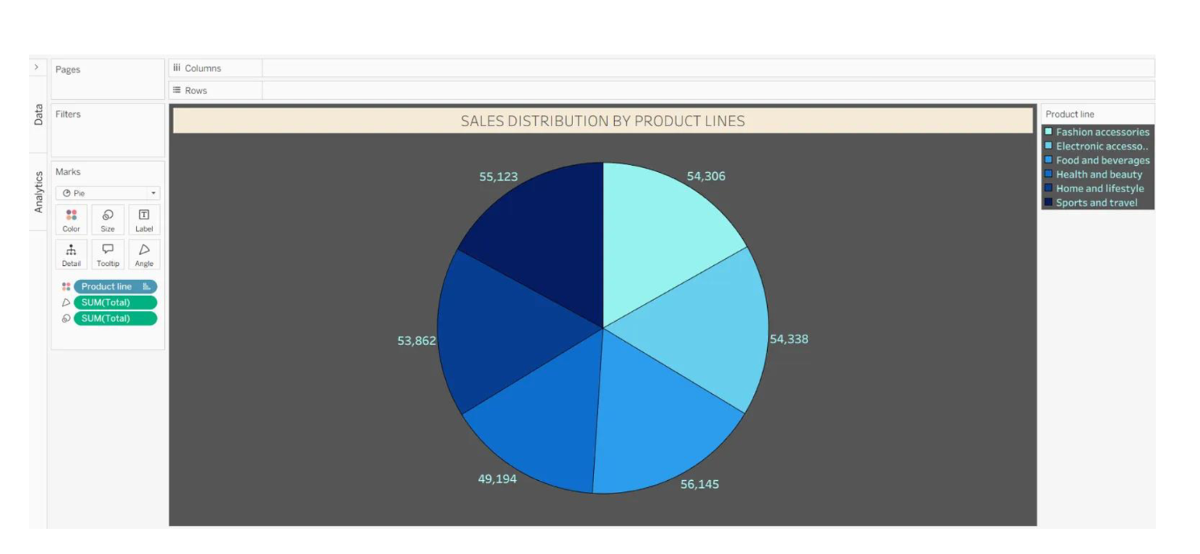

2.TOTAL SUM IN EACH CITY

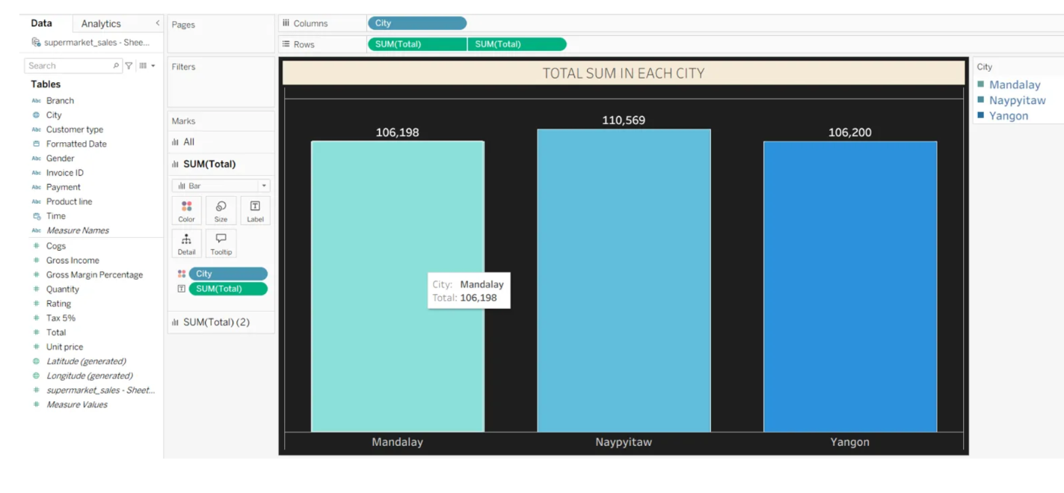

3.CUSTOMER TYPE BY PRODUCT LINES

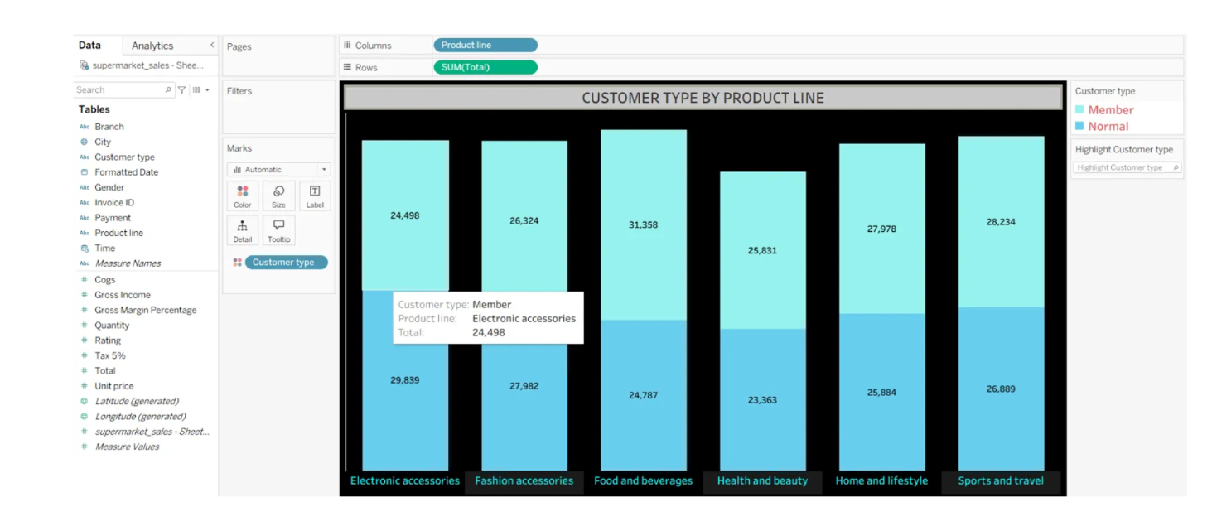

4.PAYMENT METHOD BY EACH MONTH

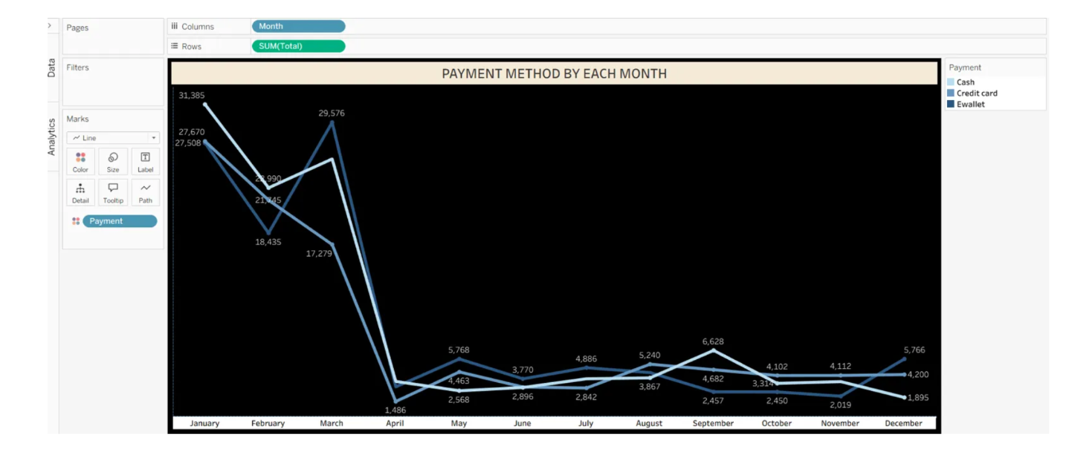

4.MONTH WISE SALES

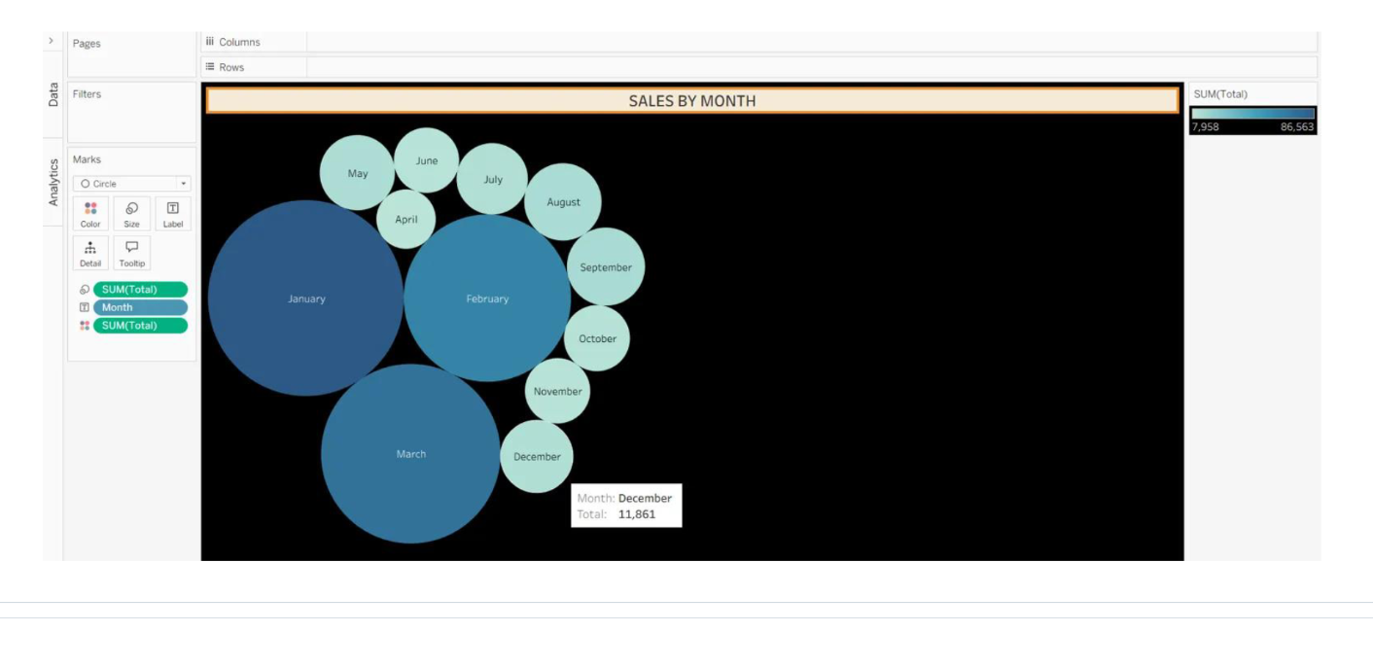

ASSIGNMENT-2

1.SALES BY PRODUCT LINE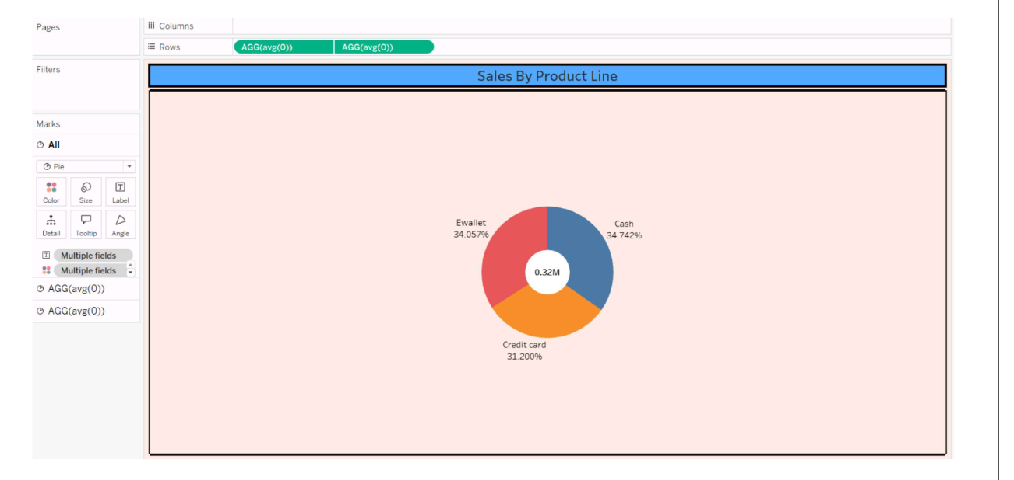

2.MONTH WISE TOTAL SALES

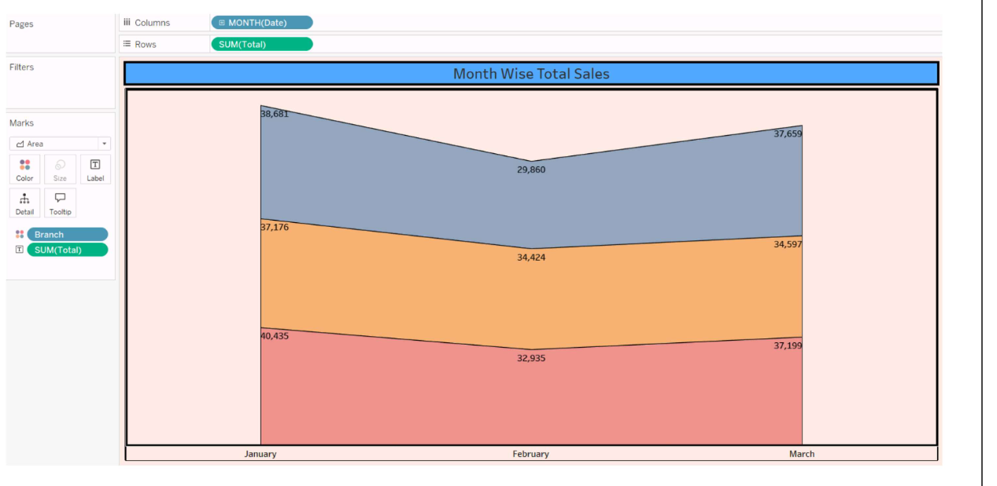

3.HIGHTLIGHT TABLE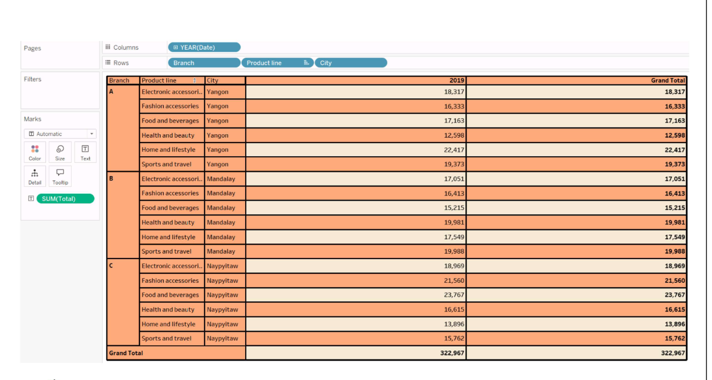

4.BRANCH WISE SALES BY PRODUCT LINE

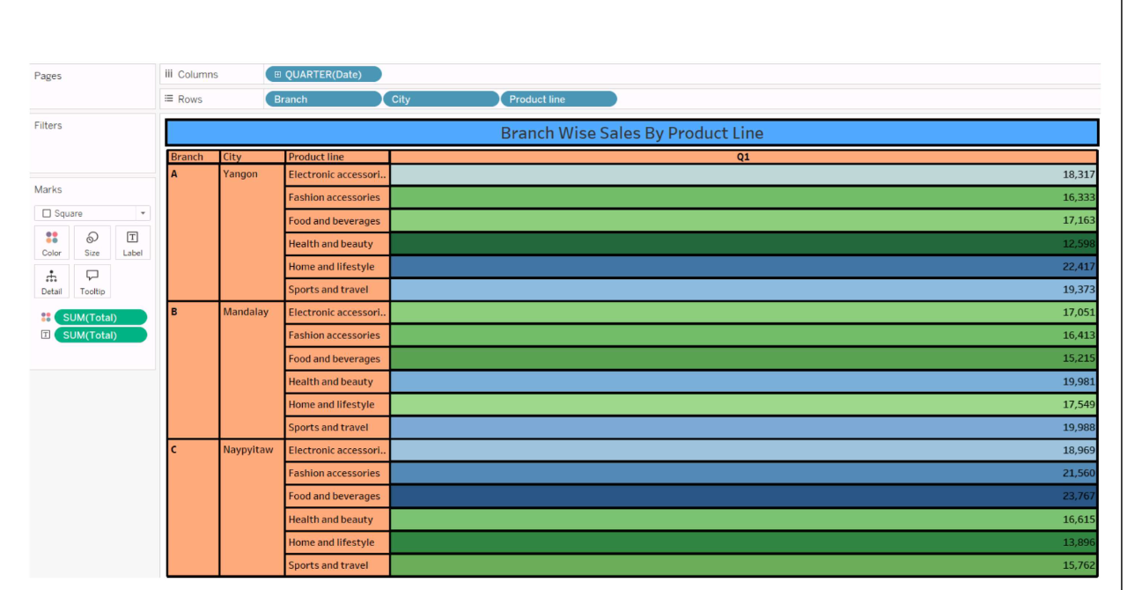

5.TOP PRODUCT LINE BY SALES

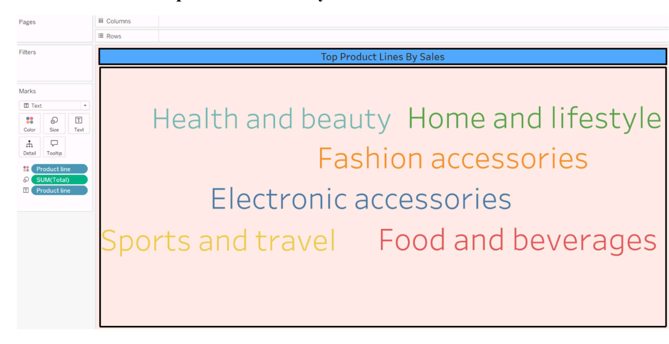

6.TOITAL SALES CONTRIBUTION BY PRODUCT LINE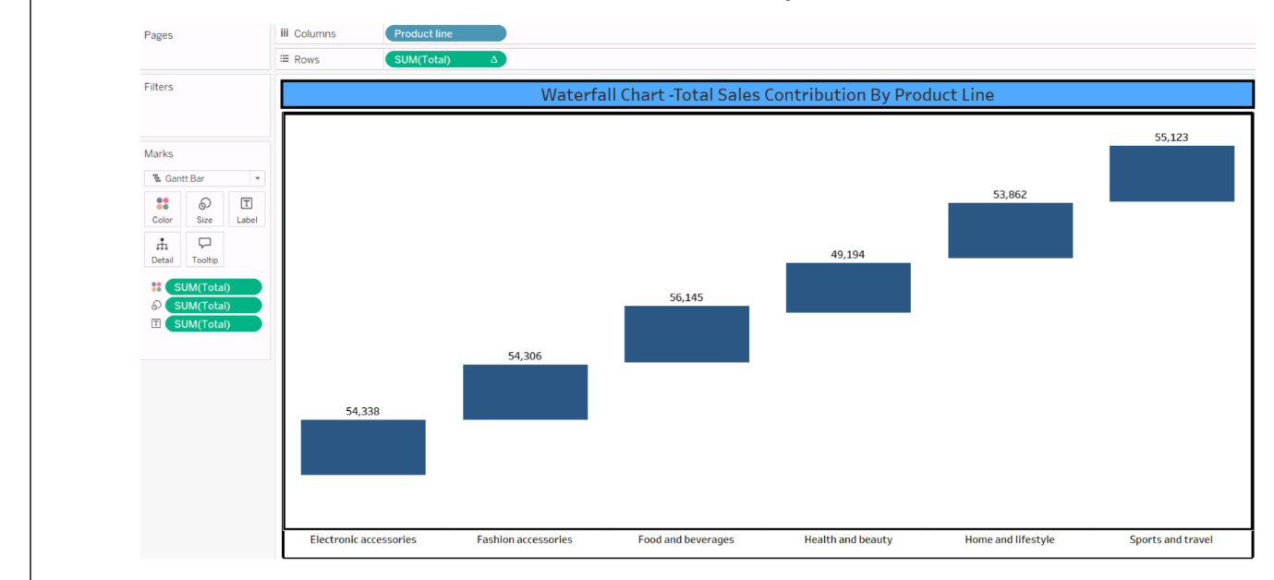

ASSIGNMENT-3

DASHBOARD-1:

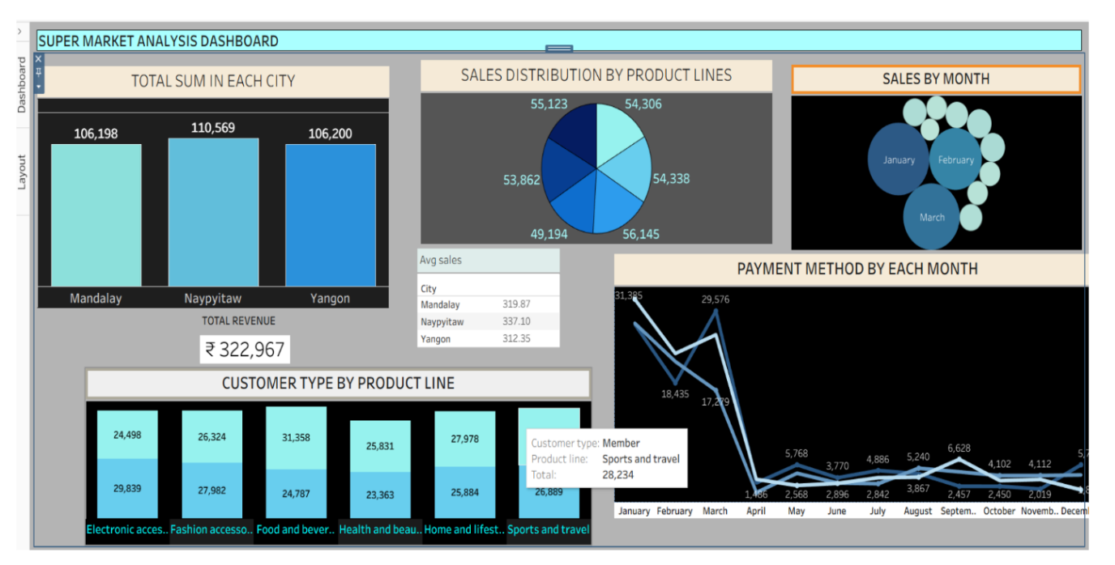

DASHBOARD-2:

